**Assignment report**

**Jianyu He**

**DT228/3**

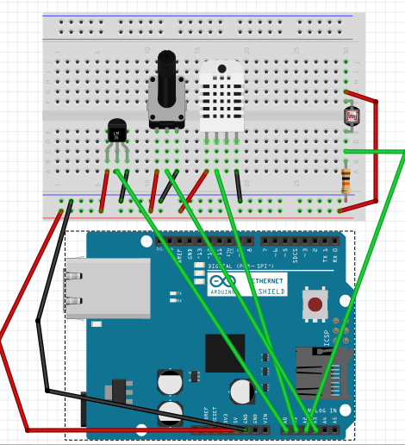

The aim of this assignment is allowed Arduino connect to internet and monitoring brightness, temperature, humidity and rotate degree of Potentiometer in google sheets. I use temboo to create connect with client and google sheets. The component of Arduino is temperature, humidity, brightness and potentiometer is respective in the Pin A0, A1, A2, A3.

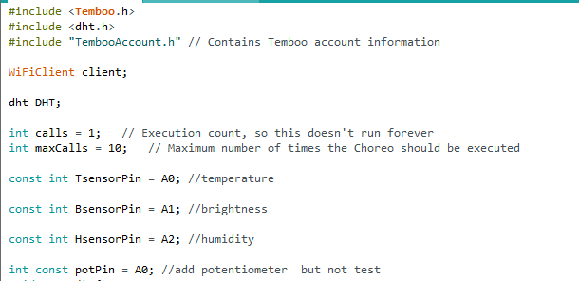

Initialize the values.

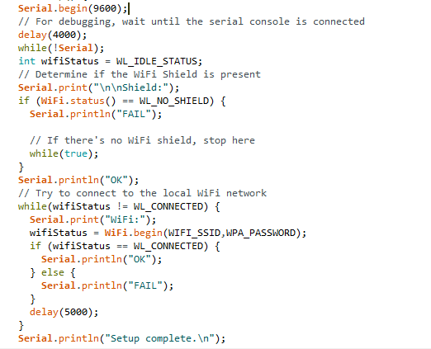

Check internet is connecting.

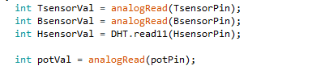

Read values from temperature, brightness, humidity and potentiometer.

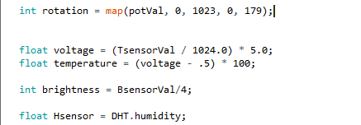

Calculate values for temperature, brightness, humidity and potentiometer.

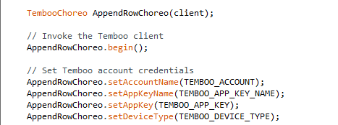

Invoke the temboo client and set temboo account credentials.

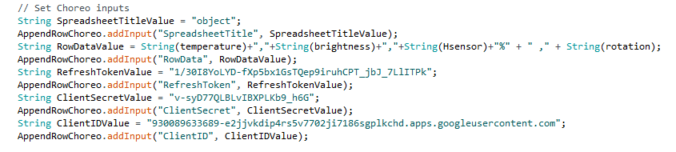

change values of temperature, brightness, humidity and potentiometer to string and insert data in to spreadsheet which name is “object” in google drive.

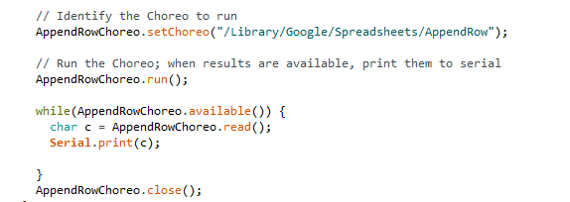



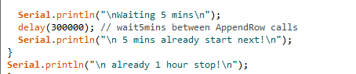

Use for loop to insert data 12 times, each interval time is 5 mins, so total is 1 hour.

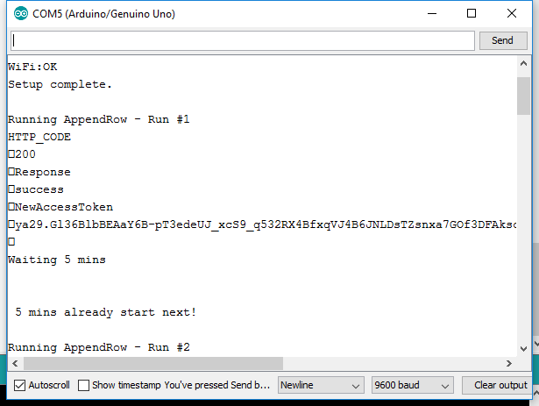

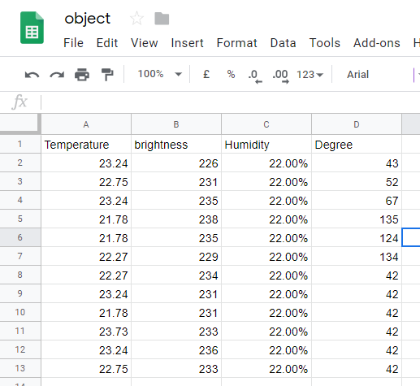

The record of temperature, brightness, humidity and degree in google spreadsheet.

Short reflection: I think use Arduino connect to internet to record data is good way to monitoring data changes. It is clearly to show data changes and easy to understand data.